Notre Dame Academy: Middle School Theology
December Prayers and Catechism Questions

□The Christmas Novena. Hail and blessed be the hour and the moment in which the Son of God was born of the most pure Virgin Mary, at midnight, in Bethlehem, in the piercing cold. In that hour, vouchsafe, O my God, to hear my prayer and grant my desire through the merits of Our Savior, Jesus Christ, and of His blessed Mother. Amen.

(This is also known as the St. Andrew Christmas Novena. Traditionally, we begin praying it on his feast day, November 30th. We recite the prayer 15 times each day leading up to Christmas )

The New St. Joseph Baltimore Catechism:
77. Did God abandon man after Adam fell into sin?
God did not abandon man after Adam fell into sin, but promised to send into the world a Savior to free man from his sins and to reopen to him the gates of heaven.
78. Who is the Savior of all men? The Savior of all men is Jesus Christ.
79. What is the chief teaching of the Catholic Church about Jesus Christ?
The chief teaching of the Catholic Church about Jesus Christ is that He is God made man.
84. Was the Son of God always man?
The Son of God was not always man, but became man at the time of the Incarnation.
88. Is St. Joseph the father of Jesus Christ?
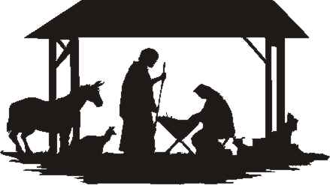
Jesus Christ had no human father, but St. Joseph was the spouse of the Blessed Virgin Mary and the guardian, or foster father, of Christ.

