Notre Dame Academy Christian Service Programs
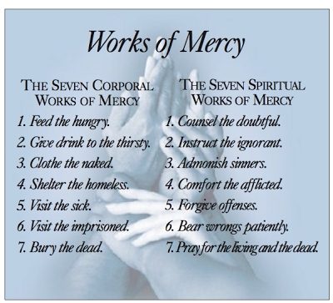
Student Name:
_______________________________

Organization Name and Address:
_______________________________
_______________________________
_______________________________

Supervisor’s Name and Email:
_______________________________
_______________________________

TO BE COMPLETED BY STUDENT:
- Please list dates and total number of hours completed:
____________________________________________________________________________________________________________________________________________________________________________________________________________________________________________________________

- Which Work of Mercy was practiced:
____________________________________________________________________________________

- Describe in detail what duties you performed or what you contributed:
____________________________________________________________________________________________________________________________________________________________________________________________________________________________________________________________

___________________________________________________ _____________________
Supervisor’s Signature Date

