Name: _____________________________________ Date: _____________ Period: __________

Notre Dame Academy: Middle School Theology
January Prayers and Catechism Questions

□The Morning Offering. O my Jesus, through the Immaculate Heart of Mary, I offer You all my prayers, works, joys, and sufferings of this day, for all the intentions of Your Sacred Heart, in union with the Holy Sacrifice of the Mass throughout the world, in reparation for my sins, for the intentions of all my friends and relatives, and in particular for the intentions of our Holy Father this month. Amen.

The New St. Joseph Baltimore Catechism:
63. Is original sin the only kind of sin? Original sin is not the only kind of sin; there is another kind, called actual sin, which we ourselves commit.
64. What is actual sin? Actual sin is any willful thought, desire, word, action or omission forbidden by the law of God.
65. How many kids of actual sin are there?
There are two kinds of actual sin: mortal and venial.
66. What is mortal sin? Mortal sin is a grievous offense against the law of God.
67. Why is this sin called mortal? This sin is called mortal, or deadly, because it deprives the sinner of sanctifying grace, the supernatural life of the soul.
70. What is venial sin? Venial sin is a less serious offense against the law of God, which does not deprive the soul of sanctifying grace, and which can be pardoned even without sacramental confession.
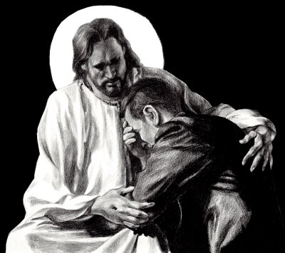
76. What are the near occasions of sin? The near occasions of sin are all persons, places, or things that may easily lead us into sin.

