Name: _____________________________________ Date: _____________ Period: __________

Notre Dame Academy: Middle School Theology
May Prayers and Catechism Questions

□The Memorare. Remember, O most gracious Virgin Mary, that never was it known that anyone who fled to thy protection, implored thy help, or sought thine intercession was left unaided. Inspired by this confidence, I fly to thee, O Virgin of virgins, my mother; to thee do I come, before thee I stand, sinful and sorrowful. O Mother of the Word Incarnate, despise not my petitions, but in thy mercy hear and answer me. Amen

The New St. Joseph Baltimore Catechism:
475. What is prayer? Prayer is the lifting up of our minds and hearts to God.
482. How many kinds of prayer are there?
There are two kinds of prayer: mental prayer and vocal prayer.
490. Why is the Our Father the best of all prayers?
The Our Father is the best of all prayers because it is the Lord’s Prayer, taught tous by Jesus Christ Himself, and because it is a prayer of perfect and unselfish love.
491. Why is the Our Father a prayer of perfect and unselfish love?
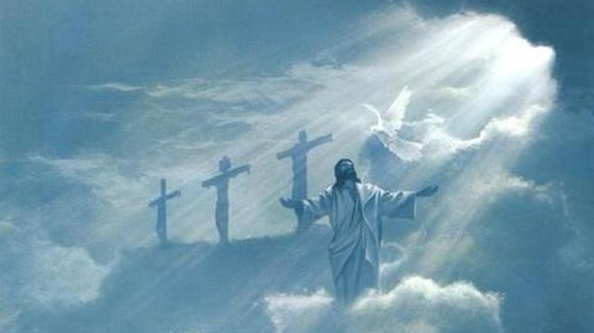
The Our Father is a prayer of perfect and unselfish love because in saying it we offer ourselves entirely to God and ask from Him the best thing, not only for ourselves but also for our neighbor.

